|  |
| --- |
| **ASSIGNMENT NO.2**    **Spring 2022**  **Computer Programming**  Submitted by: **MUHAMMAD SADEEQ**  Registration No : **21PWCSE2028**  Class Section: **C**  “On my honor, as student of University of Engineering and Technology, I have neither given nor received unauthorized assistance on this academic work.”  Student Signature: ______________  Submitted to:  **Dr. Muhammad Athar Javed Sethi**  (June 6, 2022)  Department of Computer Systems Engineering  University of Engineering and Technology, Peshawar |

**C++ PROGRAM TO FIND THE LARGEST ELEMENT OF AN INTEGER ARRAY**

**SOURCE CODE:**

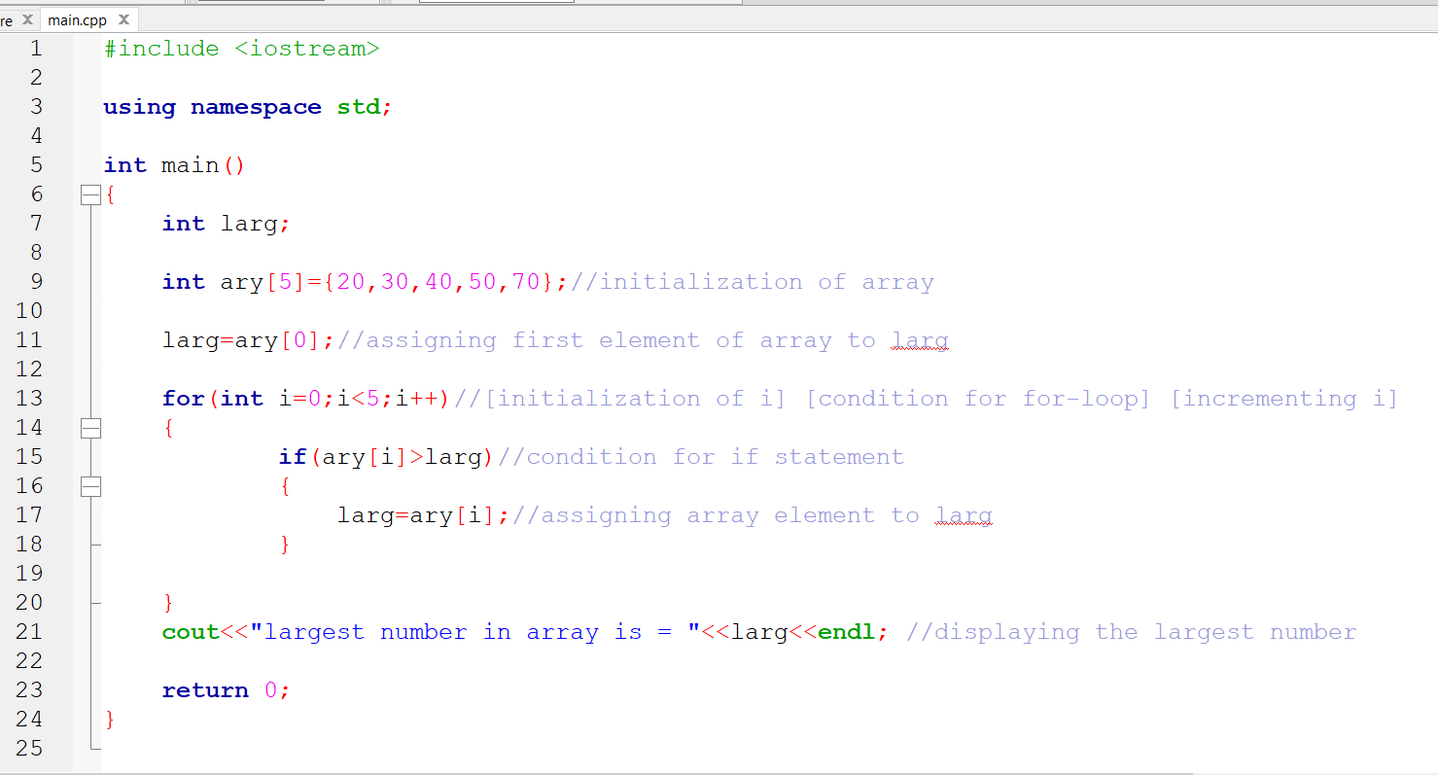

**OUTPUT:**

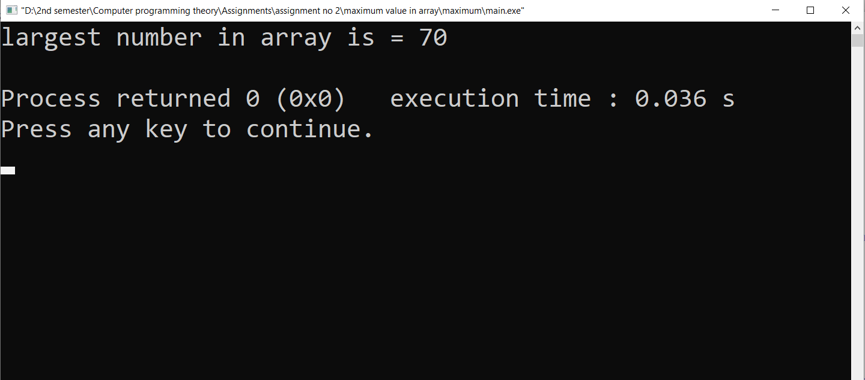

**C++ program to find the second smallest elements in a given array of integers**

**SOURCE CODE:**

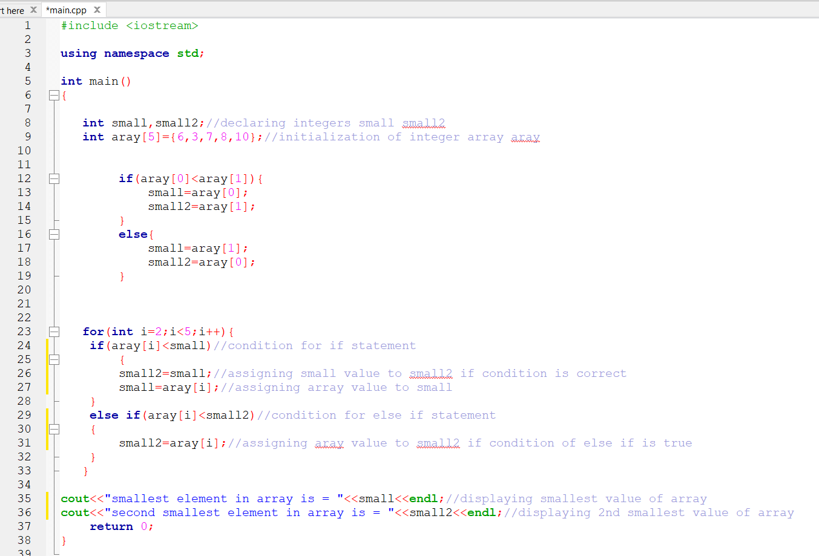

**OUTPUT:**

